

**REPORT FOR BRAIN TUMOR DETECTION IN MRI IMAGES USING DEEP LEARNING**

AS A PROJECT WORK FOR THE COURSE

**DEEP LEARNING (INT 527)**

**NAME: Suryansh partap singh SUBMITTED TO: Ms. MANBIR KAUR**

**REGISTRATION NUMBER: 12215574 DATE OF SUBMISSION:28/11/2022**

**ROLL NUMBER: 33**

**SEMESTER:** FIRST SEMESTER

**SCHOOL OF COMPUTER SCIENCE AND ENGINEERING**

**LOVELY PROFESSIONAL UNIVERSITY, JALANDHAR, PUNJAB, INDIA.**

**DECLARATION**

I Suryansh partap singh, Reg no. 12215574 hereby declare that the project work reported entitled " TO GENERATE RANDOM STORIES

” in partial fulfilment of the requirement for the award of Degree for Bachelors of Technology in CSE at Lovely Professional University, Phagwara, Punjab is an authentic work carried out under supervision of my supervisor Ms. Manbir Kaur. The content of this project represents authentic and honest effort conducted, in its entirety, by me. I am fully responsible for the contents of my project work.

Student Name: Suryansh partap singh Student Signature: 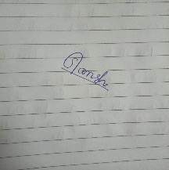

Rregistration Number: 12215574

**INDEX**

|  |
| --- |
| 1.1 INTRODUCTI0N |
| 1.2 LOOP/FUNCTION |
| 1.3 PROJECT |
| 1.4 CODE |
| 1.5 RESULT |

**1.1 PYTHON**

**Python** is a [high-level](https://en.wikipedia.org/wiki/High-level_programming_language), [general-purpose programming language](https://en.wikipedia.org/wiki/General-purpose_programming_language). Its design philosophy emphasizes [code readability](https://en.wikipedia.org/wiki/Code_readability) with the use of [significant indentation](https://en.wikipedia.org/wiki/Off-side_rule).[[33]](https://en.wikipedia.org/wiki/Python_(programming_language)#cite_note-AutoNT-7-33)

Python is [dynamically-typed](https://en.wikipedia.org/wiki/Type_system#DYNAMIC) and [garbage-collected](https://en.wikipedia.org/wiki/Garbage_collection_(computer_science)). It supports multiple [programming paradigms](https://en.wikipedia.org/wiki/Programming_paradigm), including [structured](https://en.wikipedia.org/wiki/Structured_programming) (particularly [procedural](https://en.wikipedia.org/wiki/Procedural_programming)), [object-oriented](https://en.wikipedia.org/wiki/Object-oriented_programming) and [functional programming](https://en.wikipedia.org/wiki/Functional_programming). It is often described as a "batteries included" language due to its comprehensive [standard library](https://en.wikipedia.org/wiki/Standard_library).[[34]](https://en.wikipedia.org/wiki/Python_(programming_language)#cite_note-About-34)[[35]](https://en.wikipedia.org/wiki/Python_(programming_language)#cite_note-35)

[Guido van Rossum](https://en.wikipedia.org/wiki/Guido_van_Rossum) began working on Python in the late 1980s as a successor to the [ABC programming language](https://en.wikipedia.org/wiki/ABC_(programming_language)) and first released it in 1991 as Python 0.9.0.[[36]](https://en.wikipedia.org/wiki/Python_(programming_language)#cite_note-36) Python 2.0 was released in 2000 and introduced new features such as [list comprehensions](https://en.wikipedia.org/wiki/List_comprehension), [cycle-detecting](https://en.wikipedia.org/wiki/Cycle_detection) garbage collection, [reference counting](https://en.wikipedia.org/wiki/Reference_counting), and [Unicode](https://en.wikipedia.org/wiki/Unicode) support. Python 3.0, released in 2008, was a major revision that is not completely [backward-compatible](https://en.wikipedia.org/wiki/Backward_compatibility) with earlier versions. Python 2 was discontinued with version 2.7.18 in 2020.[[37]](https://en.wikipedia.org/wiki/Python_(programming_language)#cite_note-37)

Rather than building all of its functionality into its core, Python was designed to be highly [extensible](https://en.wikipedia.org/wiki/Extensibility) via modules. This compact modularity has made it particularly popular as a means of adding programmable interfaces to existing applications. Van Rossum's vision of a small core language with a large standard library and easily extensible interpreter stemmed from his frustrations with [ABC](https://en.wikipedia.org/wiki/ABC_(programming_language)), which espoused the opposite approach.[[42]](https://en.wikipedia.org/wiki/Python_(programming_language)#cite_note-venners-interview-pt-1-42)

Python strives for a simpler, less-cluttered syntax and grammar while giving developers a choice in their coding methodology. In contrast to [Perl](https://en.wikipedia.org/wiki/Perl)'s "[there is more than one way to do it](https://en.wikipedia.org/wiki/There_is_more_than_one_way_to_do_it)" motto, Python embraces a "there should be one—and preferably only one—obvious way to do it" philosophy.[[74]](https://en.wikipedia.org/wiki/Python_(programming_language)#cite_note-PEP20-74) [Alex Martelli](https://en.wikipedia.org/wiki/Alex_Martelli), a [Fellow](https://en.wikipedia.org/wiki/Fellow) at the [Python Software Foundation](https://en.wikipedia.org/wiki/Python_Software_Foundation) and Python book author, wrote: "To describe something as 'clever' is *not* considered a compliment in the Python culture."[[](https://en.wikipedia.org/wiki/Python_(programming_language)#cite_note-AutoNT-19-75)

**1.2 LOOPS/FUNCTION**

**If….else :-** The if-else statement is used to execute both the true part and the false part of a given condition. If the condition is true, the if block code is executed and if the condition is false, the else block code is executed.

**For loop :-** A for loop is used for iterating over a sequence (that is either a list, a tuple, a dictionary, a set, or a string). This is less like the for keyword in other programming languages, and works more like an iterator method as found in other object-orientated programming languages

**list:-** it is used to store multiple item in a single variable. list are one of 4 built-in data type in python used to store collection of data, the other 3 are tuples, set, dictionary all with different quality and usage.

**Import random:** - To generate random numbers in python, we have the random module/library which needs to be imported. The random() function allows us to generate

random numbers between 0 and 1 (generates floating-point random numbers). It is a default random generator function.

**1.3 PROJECT:**

TO GENRATE RANDOM STORY

*(Student is free to decide the input and output layout for this mini project)*

**1.4 CODE:**

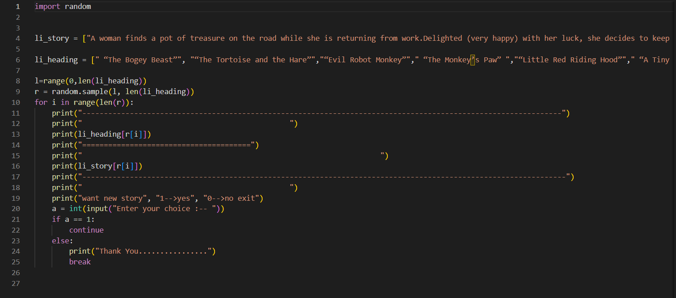

**1.5 RESULTS:**

